**DAILY ONLINE ACTIVITIES SUMMARY**

|  |  |  |  |  |  |  |  |  |
| --- | --- | --- | --- | --- | --- | --- | --- | --- |
| **Date:** | **27-5-2020** | | | | | **Name:** | **Likhitha.M** | |
| **Sem & Sec** | **6th sem ‘A’** | | | | | **USN:** | **4al17cs046** | |
| **Online Test Summary** | | | | | | | | |
| **Subject** | | **System software and compiler design** | | | | | | |
| **Max. Marks** | | **30** | | **Score** | | | **19** | |
| **Certification Course Summary** | | | | | | | | |
| **Course** | **Python for machine learning** | | | | | | | |
| **Certificate Provider** | | | **Great learning** | | **Duration** | | | **1 week** |
| **Coding Challenges** | | | | | | | | |
| **Problem Statement:**  1.Given an array arr[] of the positive integers of size N, the task is to find the largest element on the left side of each index which is smaller than the element present at that index. Note: If no such element is found then print -1. 2.Write a Java program to implement Binary Tree using the Linked List 3.Bubble sort, each pass consists of comparison each In element in the file with its successor (i.e. x[i] with x[i+1]) and interchanging two elements if they are not in the proper order. The array may be sorted in any pass. If the array is sorted, then remaining passes should be skipped off. Write a C Program to sort an array of integers in ascending order and display the sorted array and Number of passes performed for sorting. | | | | | | | | |
| **Status: completed** | | | | | | | | |
| **Uploaded the report in Github** | | | | | **yes** | | | |
| **If yes Repository name** | | | | | **https://github.com/likhithaMantaral/Daily-status** | | | |
| **Uploaded the report in slack** | | | | | **yes** | | | |

Online test Details:

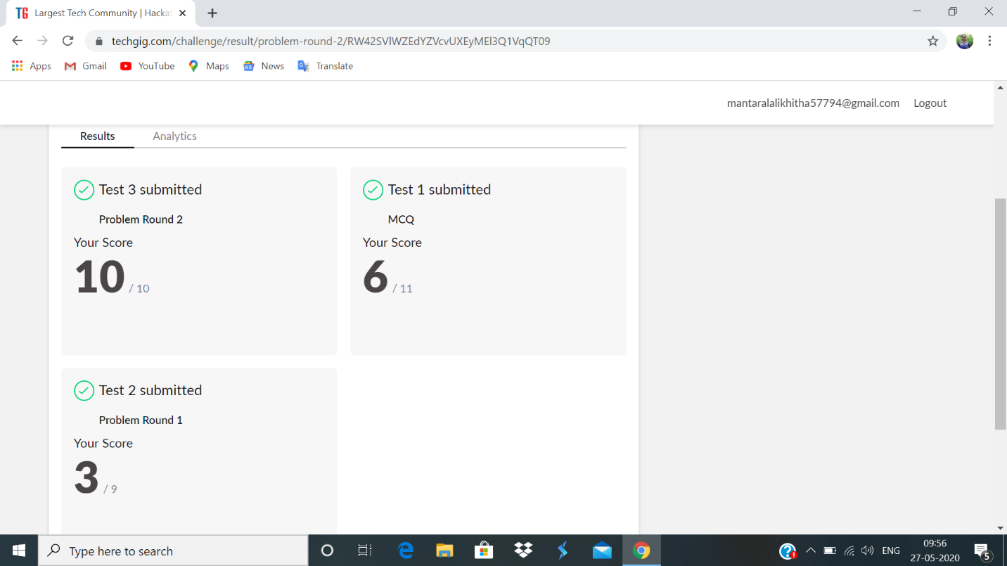

Certification Course Details:

**Saving and loading Numpy Arrays :**

In todays class learnt about Indexing numpy arrays with logicals and also saving and loading numpy arrays to file. In indexing with logicals we have to create random vector or random matrix. We can change the values in matrix or vectors using both logicals and indexes. Solved some examples.



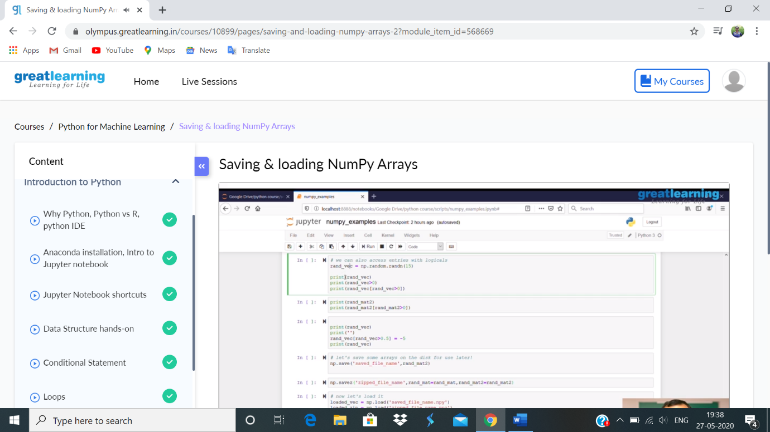

**Coding challenge:**

**1.**

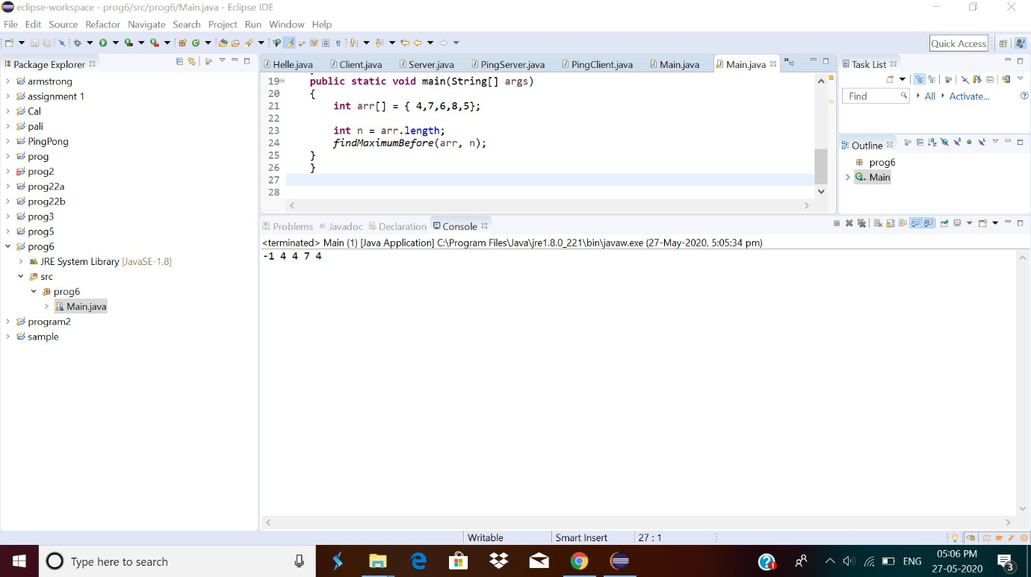

2.

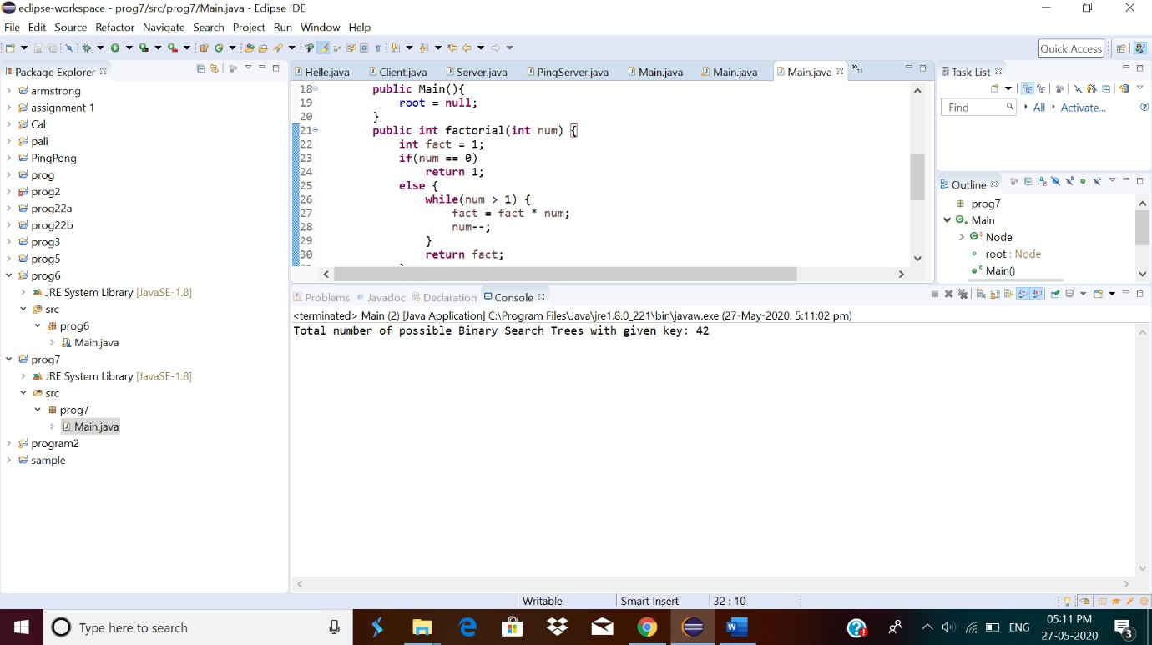

3.

